After School Environmental Learning Classes
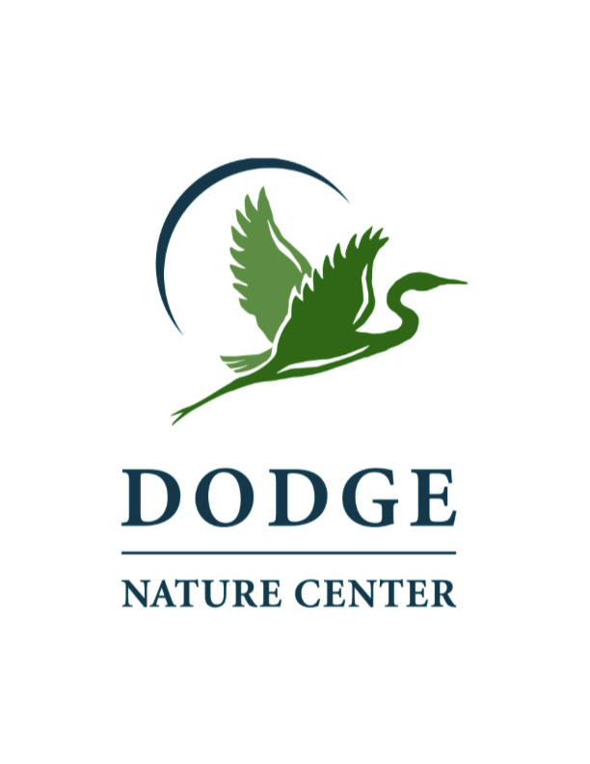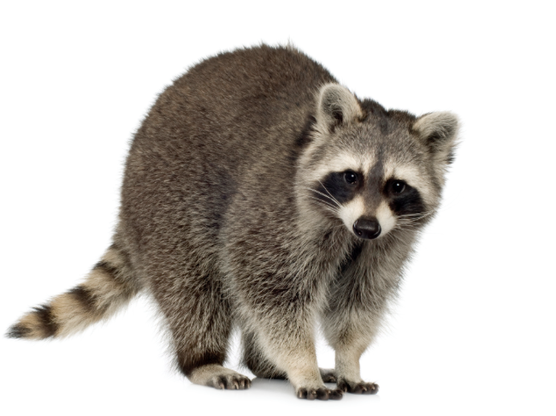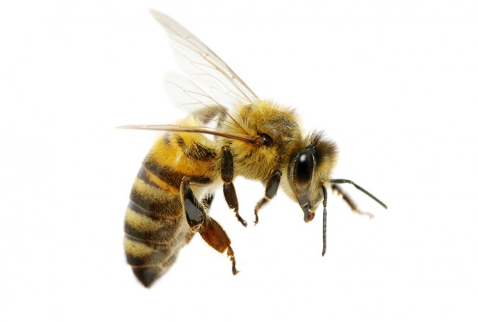
Attention 5th-8th graders:
Dodge Nature Center is offering unique after school environmental learning opportunity for you!
Radio Telemetry-Raccoon Research
Ever wondered where raccoons are going during the daytime? to sleep? Or during the year? Let’s find out! Learn about raccoons and follow a pair of collared raccoons over the course of this school year. Use radio telemetry equipment to track their location. This is the same equipment you see on nature shows on TV. Then chart their movements by plotting data points to make a map of animal movement over time. How is wildlife field research done? Let’s learn! Your instructor will be Don Oberdorfer.

Meeting dates: Sept. 23, Oct. 21, Nov. 18, Dec. 16, Jan. 20, Feb. 24, March 23, April 20, May 25
Time: 3:15-4:30
Cost: $90
Location: Dodge Nature Center
Bussing will be arranged after school to Dodge Nature Center. Parents will need to pick students up from the Dodge Nature Center Farm Entrance at 1735 Charlton Street at 4:30 p.m.

Registration deadline: Sept. 16, 2015

Bee Keeping 101
Think all flying insects are the same? Want to get up close and personal with honey bees? Come learn the basics of beekeeping from what makes a bee a bee to what’s in a hive to harvesting honey. Classes will include indoor learning sessions, suiting up to monitor our hives, and tasting honey. Your instructor will be Pam Welisevich.
Meeting dates: Jan. 12, Feb. 9, March 8, April 12, May 10, May 31
Time: 3:15 – 4:30 p.m.
Cost: $60
Location: Dodge Nature Center
Bussing will be arranged after school to Dodge Nature Center. Parents will need to pick students up from the Dodge Nature Center Farm Entrance at 1735 Charlton Street at 4:30 p.m.

Registration deadline: Dec. 21, 2015

Register at the Heritage school office with a check (payable to Dodge Nature Center) or cash. Scholarships are available based on financial need. Please contact Kristin Dirksen with any questions. E-mail: Kristin.Dirksen@isd197.org

